**SOFTWARE REQUIREMENTS SPECIFICATIONS**

**FOR**

**“MY TWITTER CLONE”**

**Prepared By:**

**AMIT NAUTIYAL**

**BHARAT KHURANA**

[](http://www.google.co.in/url?sa=i&rct=j&q=&esrc=s&frm=1&source=images&cd=&cad=rja&uact=8&ved=0ahUKEwi_r5WHx6PJAhWj2qYKHSY4DaIQjRwIBw&url=http://www.payscale.com/research/IN/Employer=Computer_Sciences_Corporation_(CSC)/Salary&psig=AFQjCNHypt3u09-yEthCtgukYJ-9bFrZhQ&ust=1448265360466822)

**PRE-JOINING TRAINING**

**SECTOR-62,NOIDA**

**CSC INDIA**

**ACKNOWLEDGEMENT**

No work is considered complete unless due acknowledgement is given to those who made the work possible.We take this opportunity to profusely thank Mr. Rajeev Kumar Mohan, who made this project a success. His unforgettable, positive approach made this project possible.

These 35 days have been a gratifying experience for us and have brought us in contact with professionals who have positively contributed to our vision knowledge and understanding of the technical and social aspects of software engineering.

Words at our command are inadequate both in form and spirit to express our sincere and profound gratitude to *Mr. Vibhor,* our Project Mentor for his support, guidance, and whole -hearted help throughout the course of our project.

We are indebted to all those who directly or indirectly contributed for making this project a reality.

**TABLE OF CONTENTS**

1. **Project Undertaken**

1.1 Project Scope

1.2 Technologies/framework used

1. **Overall Description**
   1. Database Design
   2. Tables
   3. Use Case Model
2. **Class Diagrams**
3. **Activity Diagrams**
4. **Screenshots of Project**
5. **PROJECT UNDERTAKEN**

The project titled as “My Twitter Clone “is a web based application. This application provides facility for social networking as a whole.

**1.1Project Scope**

This specification that defines the functional requirements of the system are:

* It includes certain features like login,signup, tweet, follow etc.
* Users are able to visit the application and Sign up
* Registered users, hereinafter referred to as “Users”, are able to tweet from their home page .
* Users are able to edit or delete their own *tweet*
* Users are able to edit their profile (change password, update name,etc.)
* Users are allowed to change their *username*.
* Users are able to search other registered users
* Users are able to *follow* other users.
* Users are able to receive tweets from people they follow
* User is able to recover his account in case he forgets his username and password.
* Also this application assigns a unique username.
* The designed project is Responsive.

### 1.2 Technologies/framework(s) used

* Software : Eclipse (Juno)
* Database : MySQL 5.1
* Server : Tomcat 7.0
* Language : Java 1.7
* Servlet 2.0
* JSP 2.0
* Web technology design : Ajax ,CSS, Html, jQuery ,Bootstrap
* Validation : JavaScript

2.Overall Description

**2.1 Database Design**

A person has a one-to-many relation with a tweet (1 person -> many tweets). Similarly, a person has a

1->N relation with others in the form of following and followers, i.e.

* + - A person can have many followers
    - A person can follow other persons

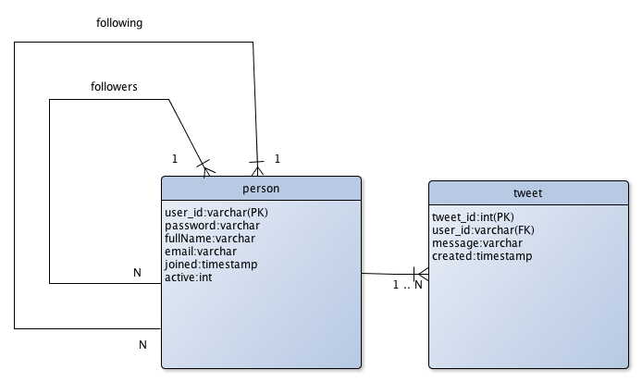

### 2.2 Tables

**PERSON**

|  |  |  |  |
| --- | --- | --- | --- |
| **Column** | **Type** | **Size** | **Not Null** |
| user_id (PK) | varchar | 25 | Y |
| password | varchar | 100 | Y |
| fullName | varchar | 30 | Y |
| Email | varchar | 50 | Y |
| Joined | timestamp | - | Y |
| active | int | 1 | Y |

***password* – Stored in encrypted using SHA**.

**FOLLOWING**

**(table representing the relation between persons ie. Following & Followers)**

|  |  |  |  |
| --- | --- | --- | --- |
| **Column** | **Type** | **Size** | **Not Null** |
| user_id (FK) | varchar | 25 | Y |
| following_id(FK) | varchar | 25 | Y |

**TWEET**

|  |  |  |  |
| --- | --- | --- | --- |
| **Column** | **Type** | **Size** | **Not Null** |
| tweet_id(PK) | int (Auto increment) | 10 | Y |
| user_id(FK) | varchar | 25 | Y |
| message | varchar | 140 | Y |
| created | timestamp | - | Y |

**SECURITYCHECK**

|  |  |  |  |
| --- | --- | --- | --- |
| **Column** | **Type** | **Size** | **Not Null** |
| user_id(PK) | varchar | 25 | Y |
| password | varchar | 100 | Y |
| fullName | varchar | 30 | Y |
| answer | varchar | 30 | Y |
| email | varchar | 50 | Y |

**PK *- Primary Key,* FK *- Foreign Key***

**2.3 use case model**

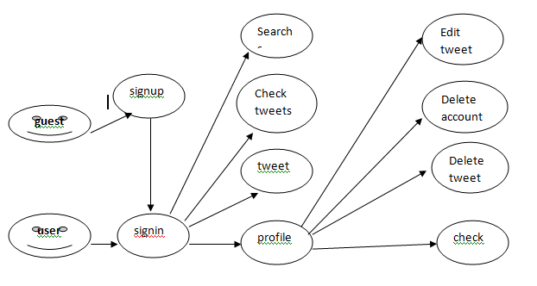

1. **CLASS DIAGRAMS**

* **LOGIN**

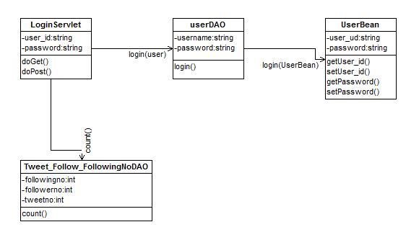

* **SIGNUP**

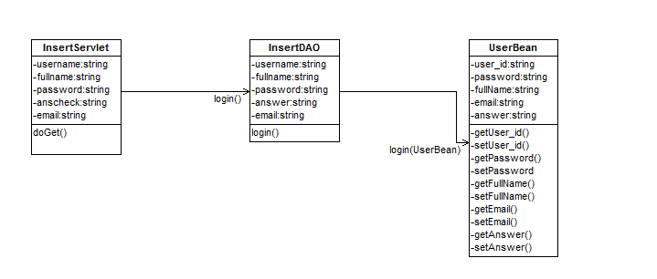

* **TWEET**

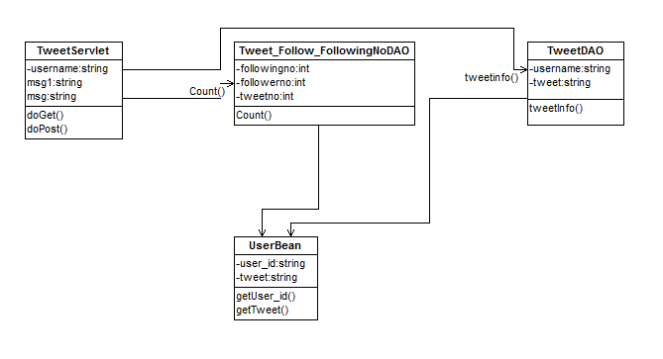

* **EDIT TWEET**

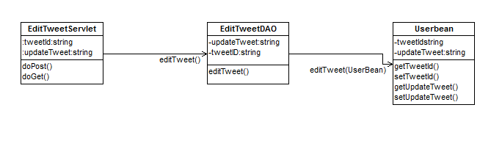

* **FOLLOW**

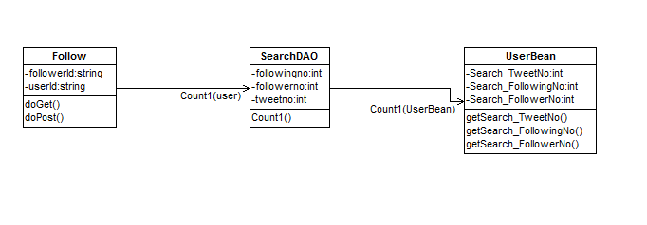

1. **ACTIVITY DIAGRAMS**

* **LOGIN**

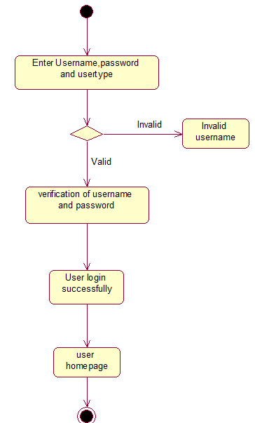

* **SIGNUP**

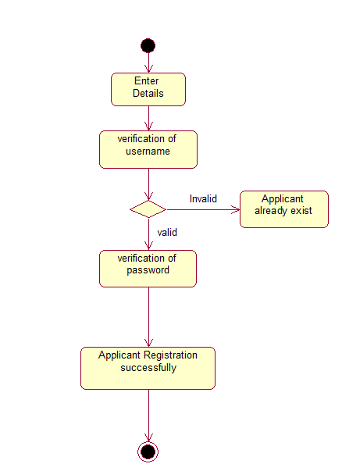

* **CHANGE PASSWORD**

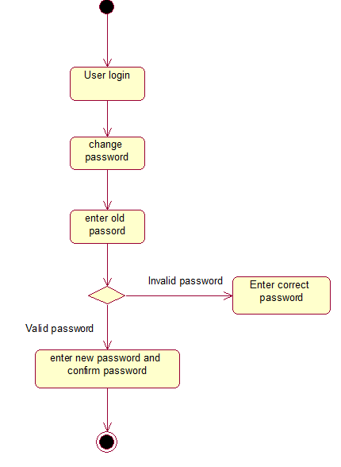

1. **SCREENSHOTS**

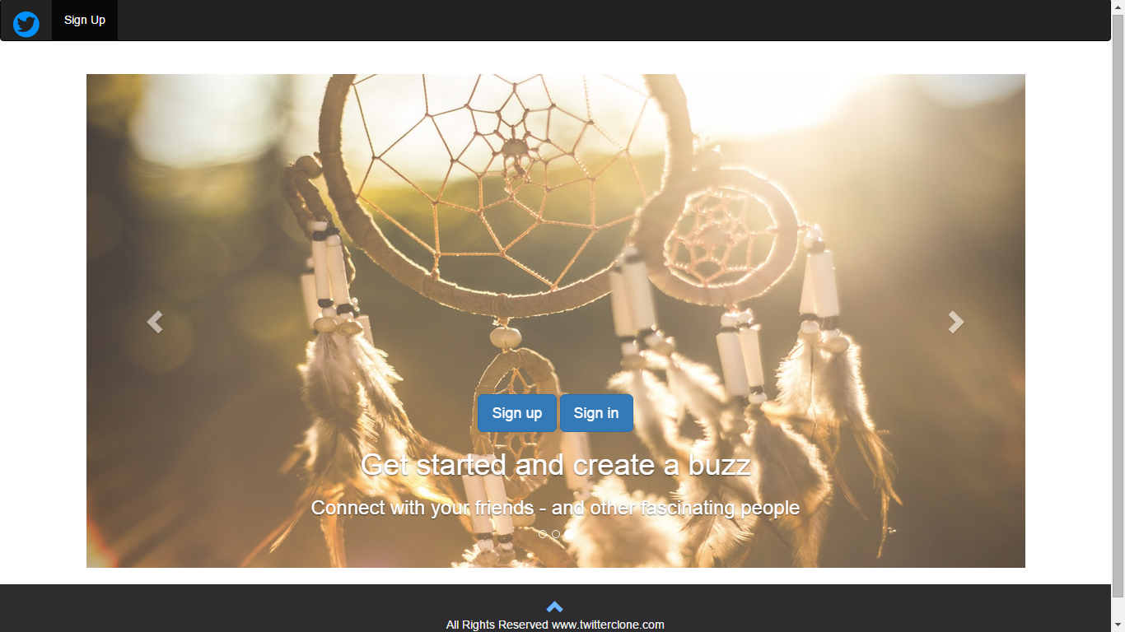

**FRONT PAGE**

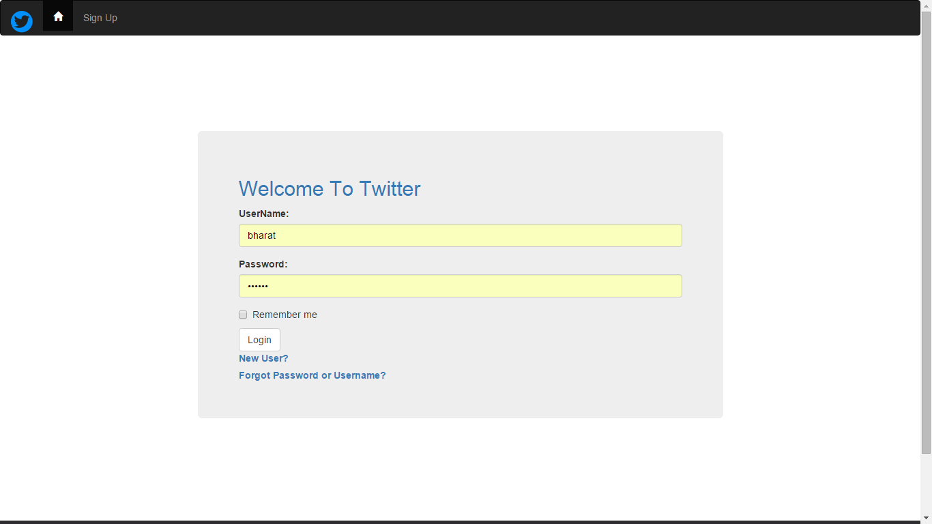

**LOGIN PAGE**

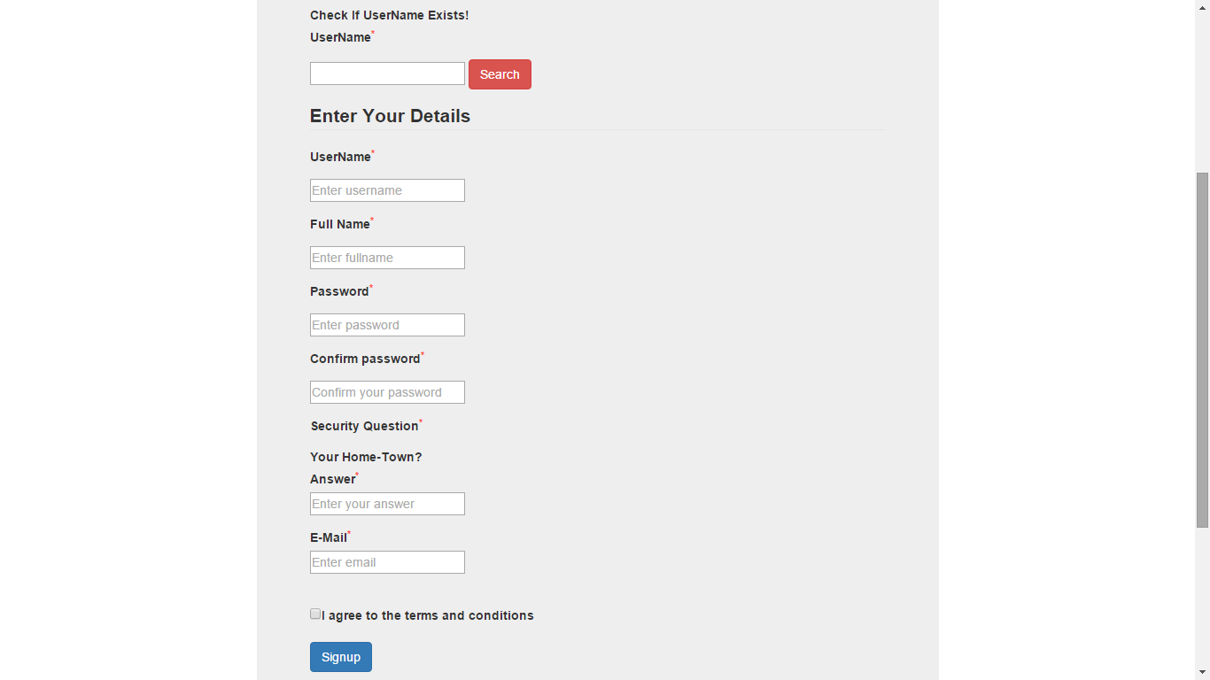

**SIGN UP PAGE**

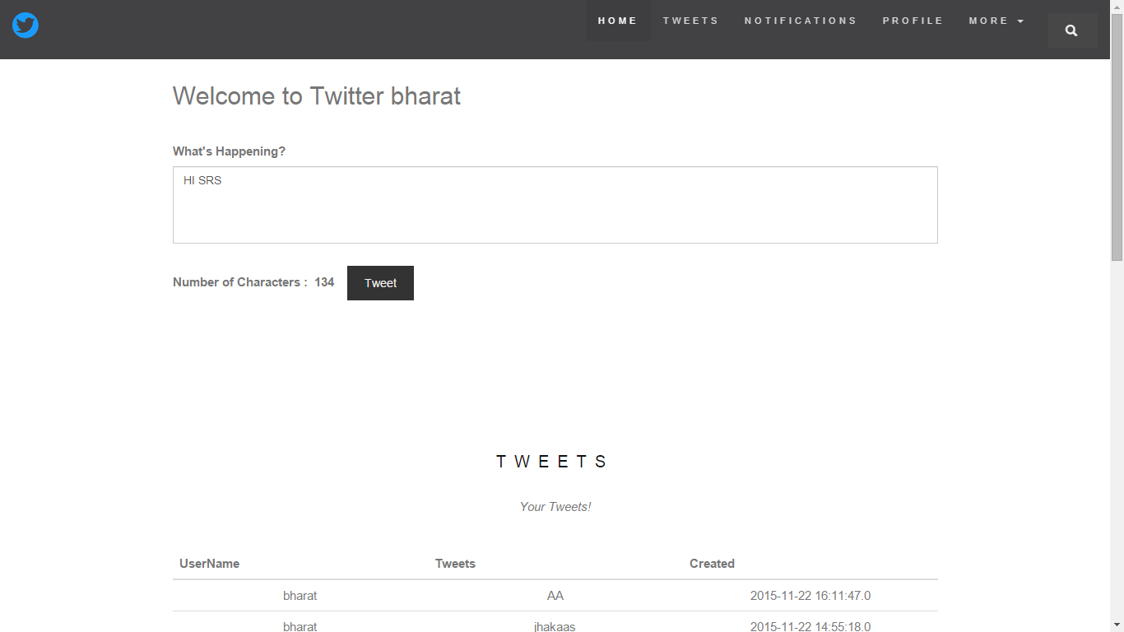

**HOME PAGE**

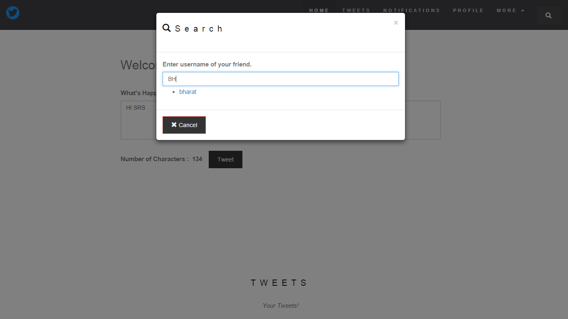

**SEARCH FRIENDS**

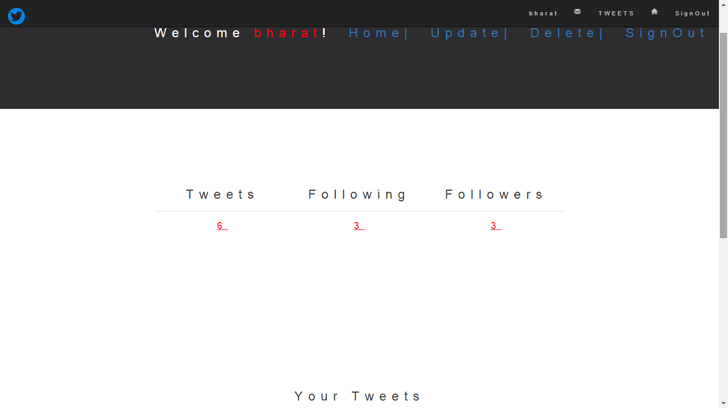

**ADMIN PROFILE**

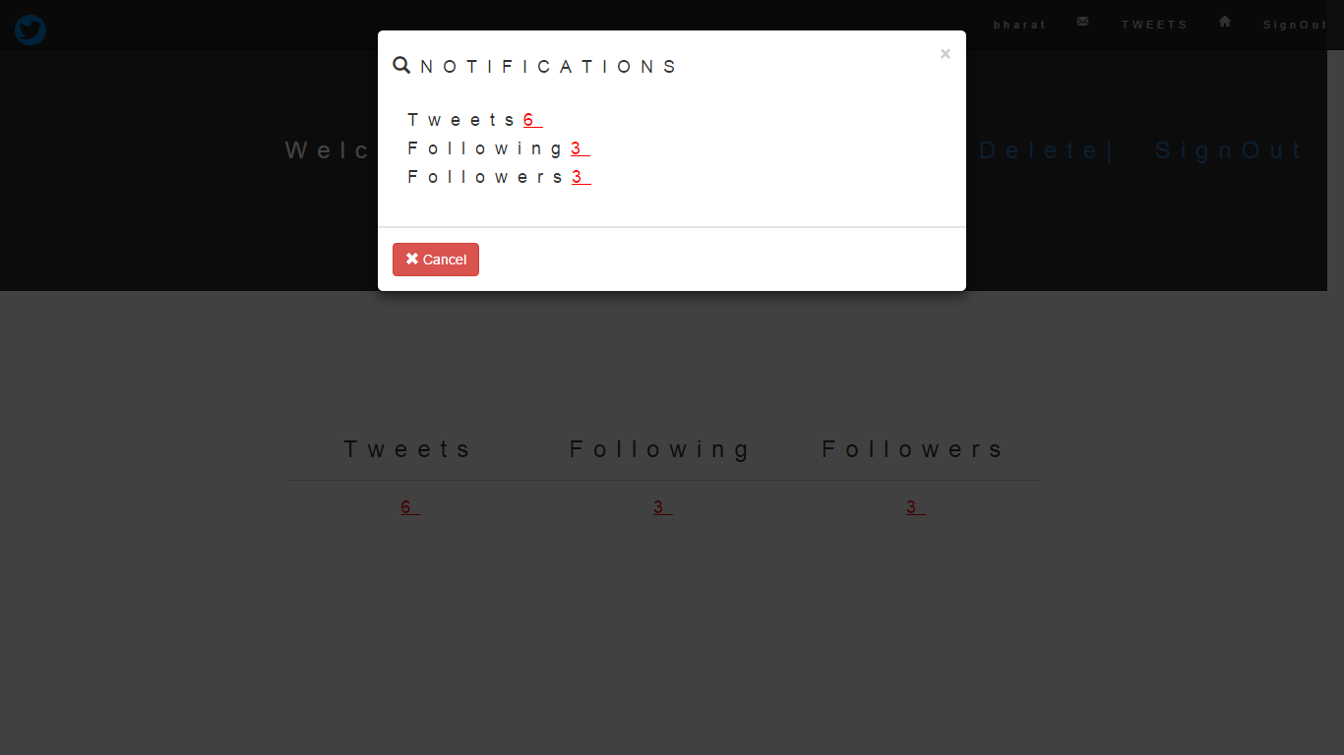

**ADMIN NOTIFICATIONS**

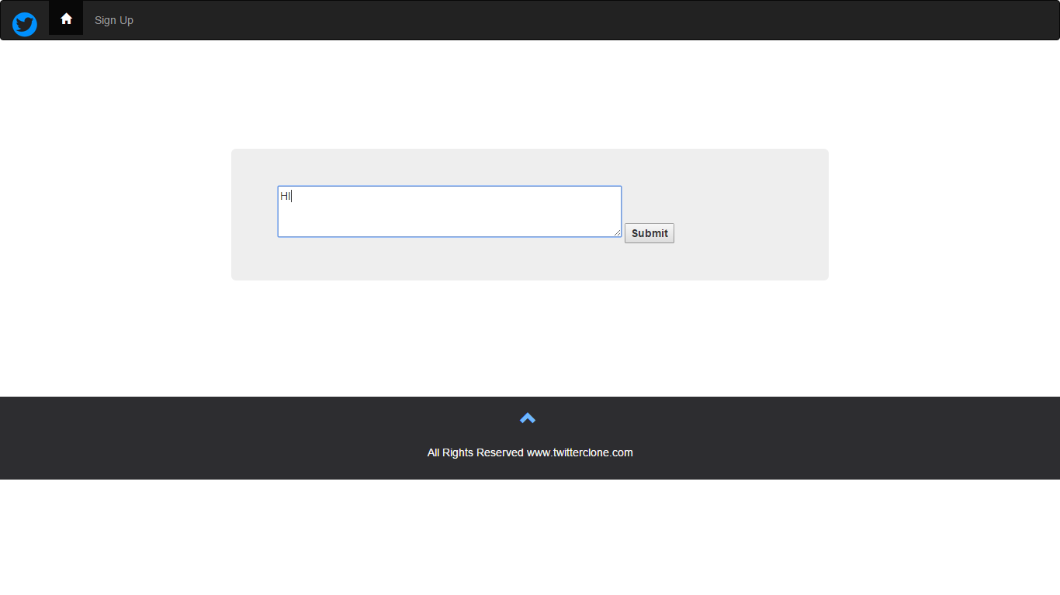

**EDIT TWEET**

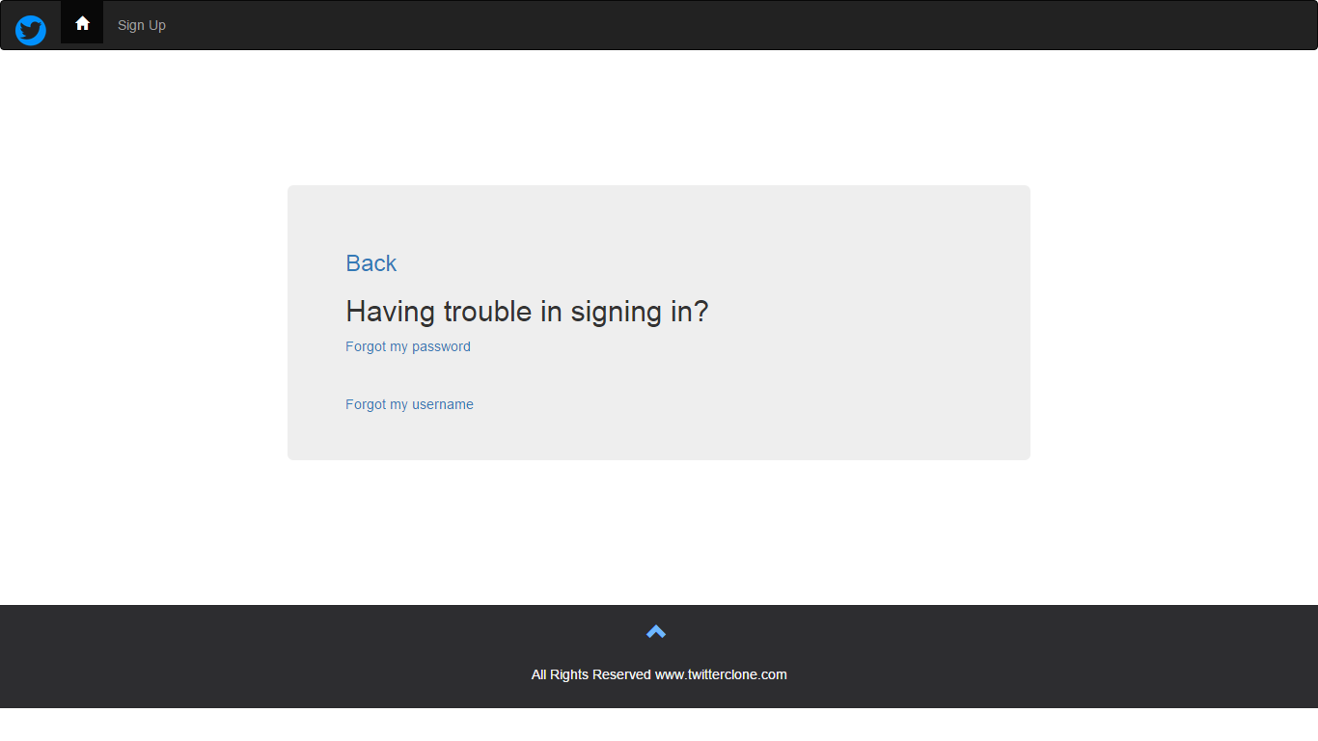

**HELP**

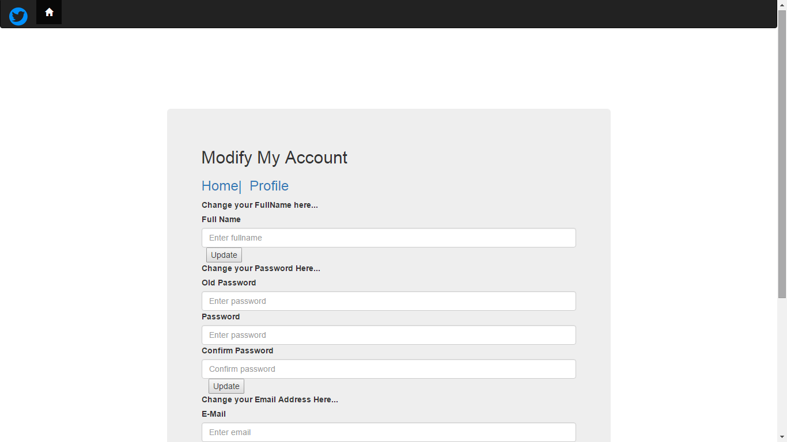

**ADMIN UPDATES**